=====8/12/2022=====

Group ID: 07

Project name: Cadger

Prepared by: **Nguyễn Khải Phú**

Team members:

20127124 - **Đặng Bảo Châu** *Project manager*

20127062 - **Nguyễn Khải Phú** *Process engineer*

20127068 - **Hồ Minh Thanh Tài** *Business Analyst*

20127045 - **Võ Đình Khôi** *Test Manager*

20127406 - **Thái Cẩm Phong** *Software Engineer*

# **Summarize**

Heavy work was expected this week. Deadlines were set appropriately in order to give the whole team enough time. Everyone worked well and met their deadlines. Mr. Tài is currently facing serious health issues, and is not included in this week’s assignment. This unexpected problem exposed the vulnerability and rigidness of the team’s workflow. The team is going to plan appropriately and have better preparations going into next week.

1. **Screenshots of all tasks**

* Bảo Châu

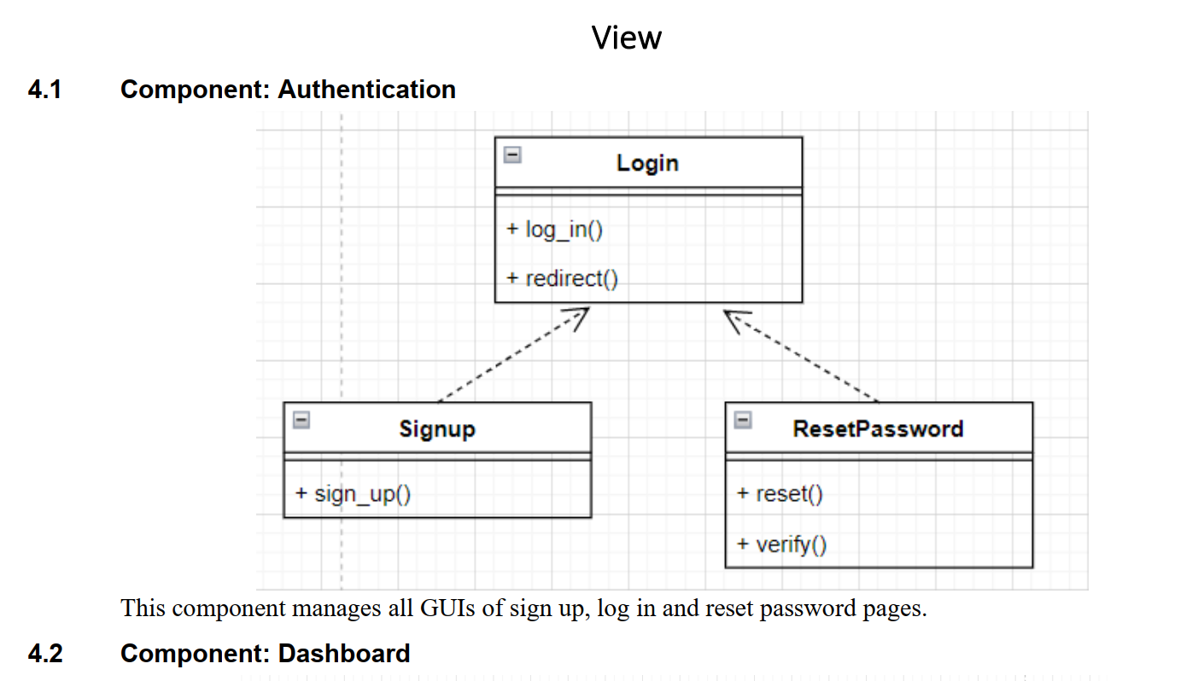

* Đình Khôi

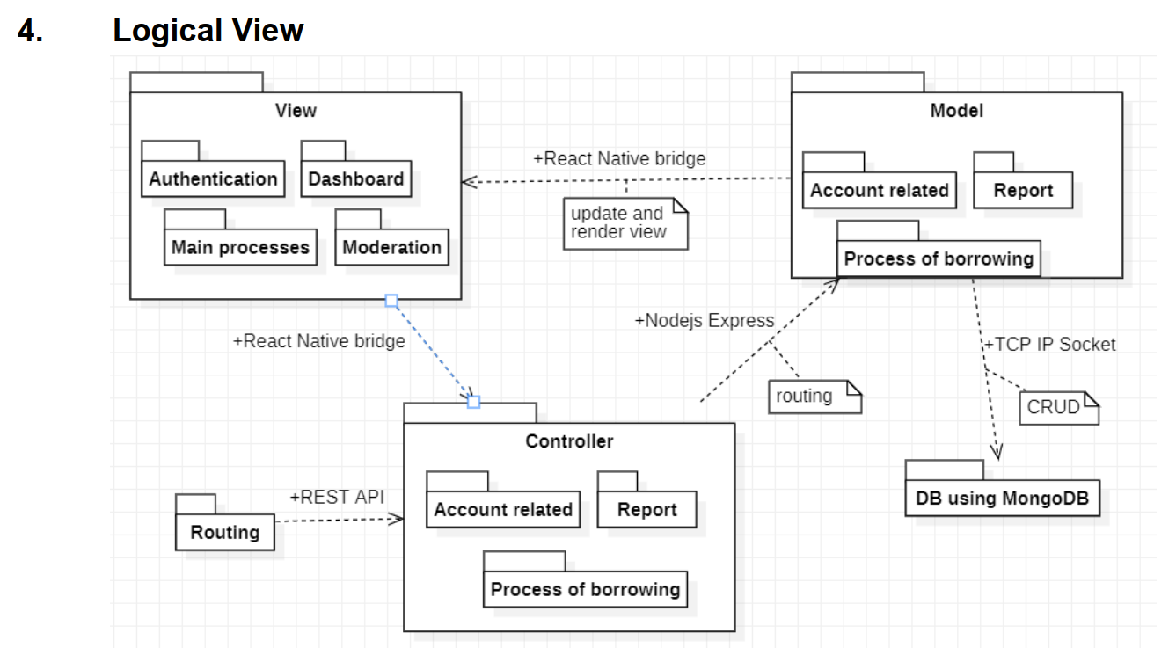

* Khải Phú

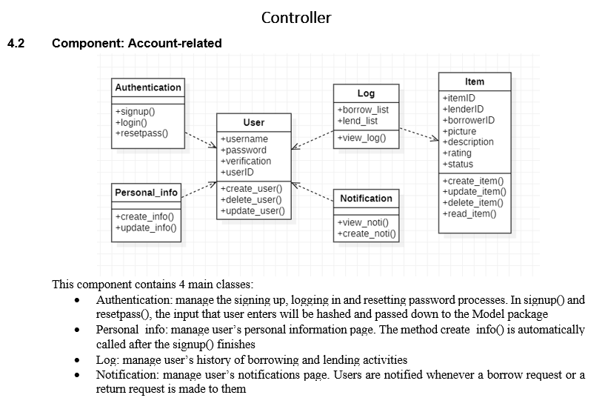

* Cẩm Phong

